How are revenue, number of orders, and average order value changing over time?
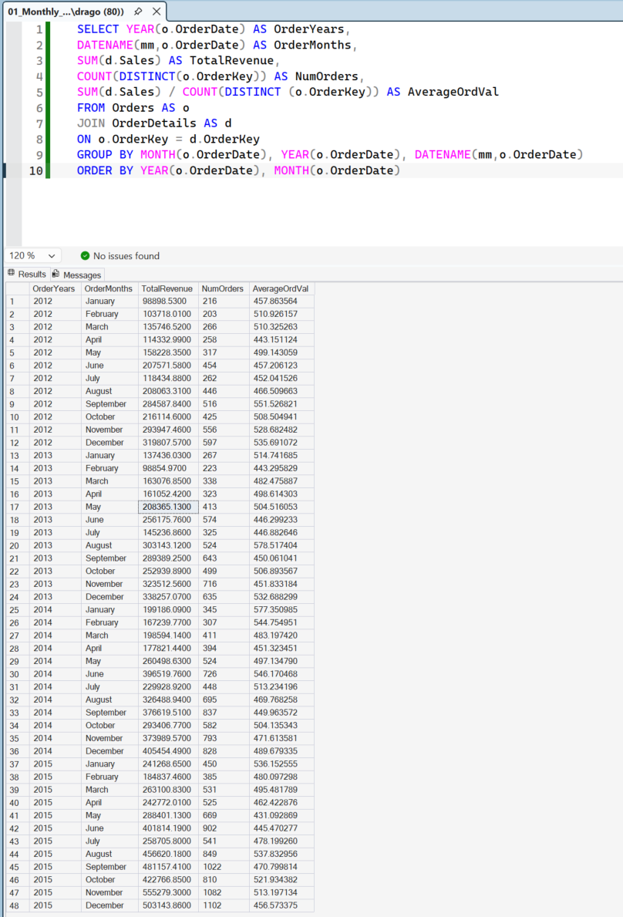
Business Insight:
From the data we can infer that the company is experiencing consistently strong growth over the years. Not every consecutive month is with higher revenue than the previous but overall, the company thrives. By looking at the number of orders, we can notice that the growth is driven by more orders (attracting more customers), rather than customers spending more per order.

Who are the top 10 customers by revenue, and how profitable are they?

Business Insight:
From the data we can conclude that the people with who have generated us the most revenues aren’t the ones who have made us the most profit from there orders. There are even customers from which we have lost money. This is a sign that we should reconsider shipping costs, material costs, discounts or even the product mix.

Which customer segments generate the most revenue and profit?
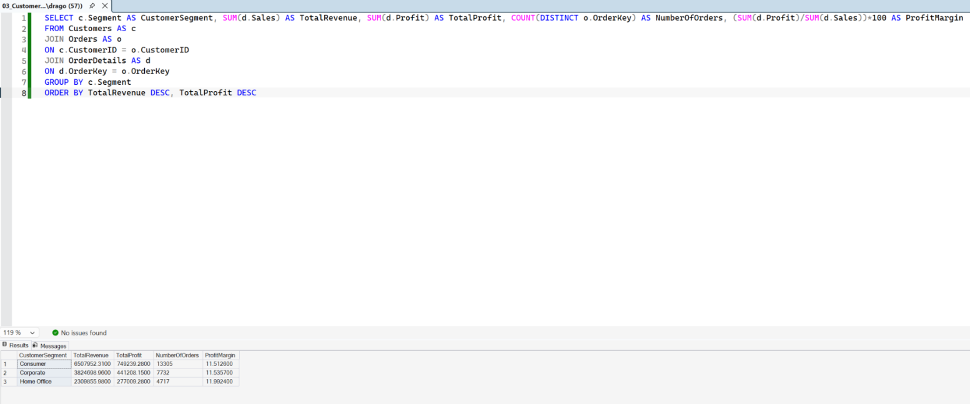
Business Insight:
From the table we see that the Consumer segment is the company’s largest segment in terms of total revenue, profit and number of orders. However, Corporate and Home Office segments have higher profit margins.

Which product categories and sub-categories are the most and least profitable?
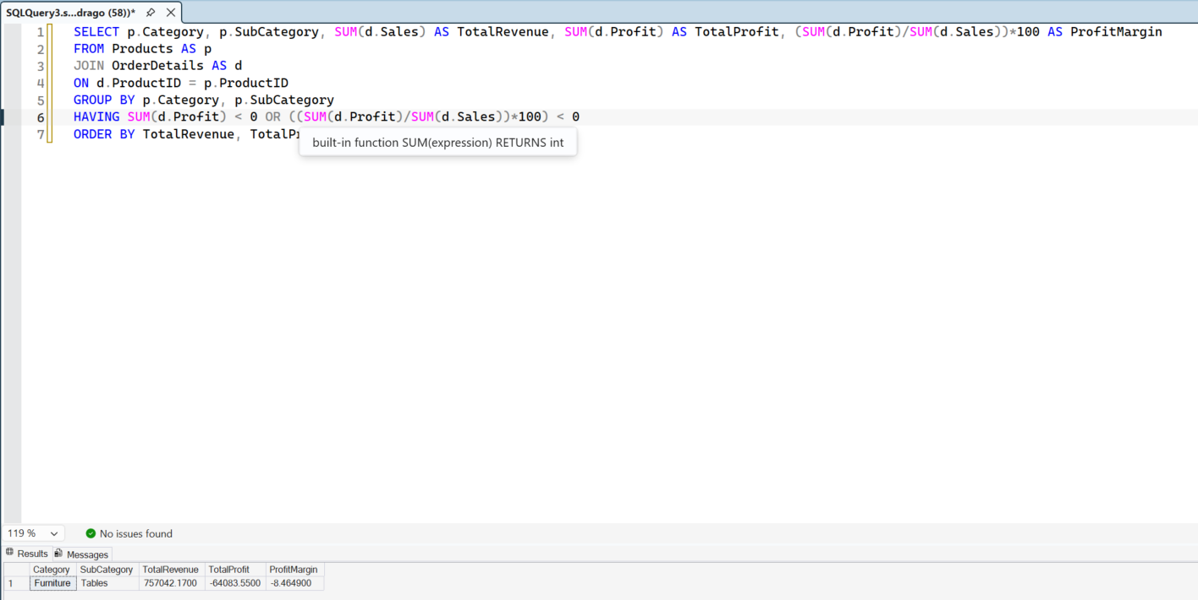
Business Insight:
I returned the category and the subcategory of the product with negative total profit and profit margin. Therefore, investigation should be done to be found why this product makes the company losing money.

Which products generate high sales but poor or negative profitability?
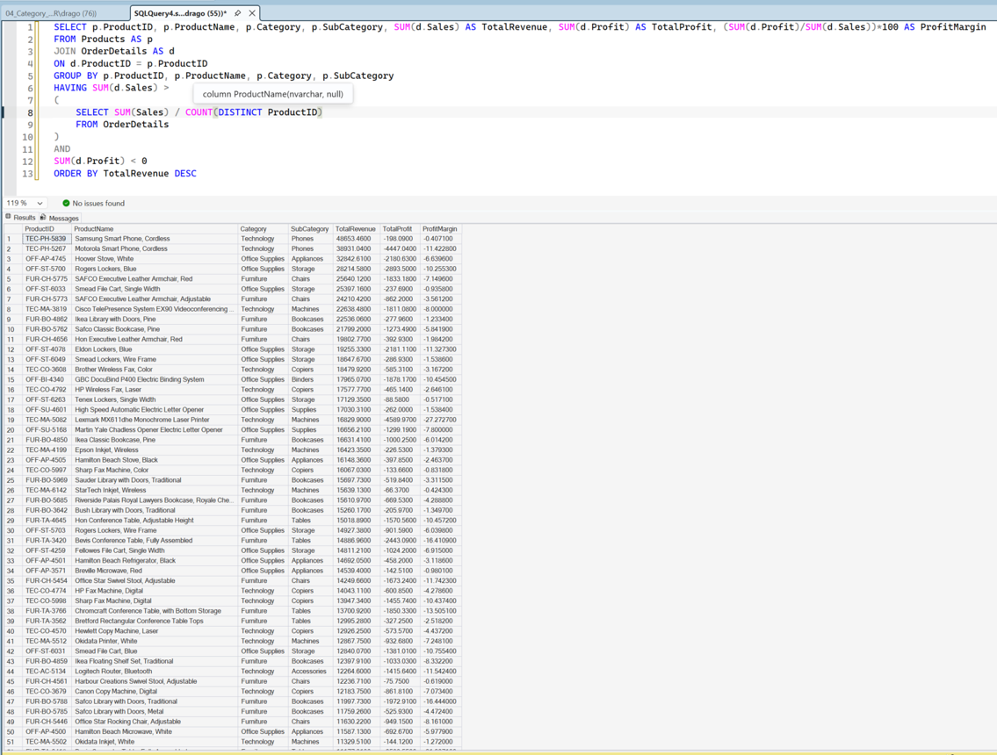

Business Insight:
From the data in the table, we can infer that there are lots of products generating revenue above the average but remain with negative profit and profit margin. This identifies that we have products with strong sales which do not make us money. Therefore, we should overview our product strategy for further developments. Moreover, we can also deduce that the issues come from multiple product categories which means that product strategies should be observed individually rather than searching for correlation withing certain categories or subcategories.

Which countries contribute the most to company revenue and profit, and are their profit contributions proportional to their revenue contributions?
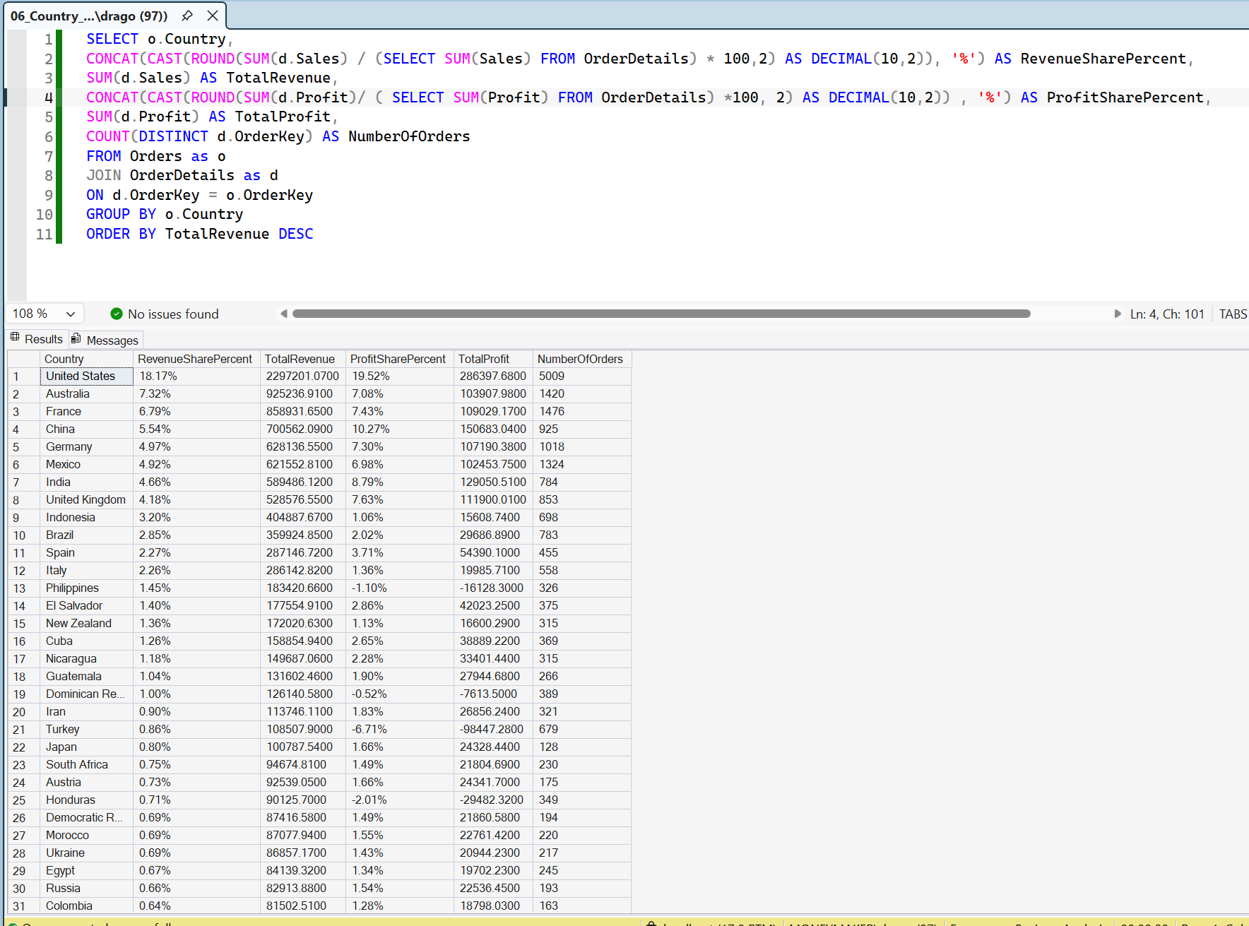

Business Insight:
The result from the database shows us the contribution to the total revenue and total profit in % for different countries the company operates in. We can clarify stronger countries as China and India which contribute substantially more to our profit than revenue in our business.

How do different discount levels affect sales volume, revenue, and profitability?
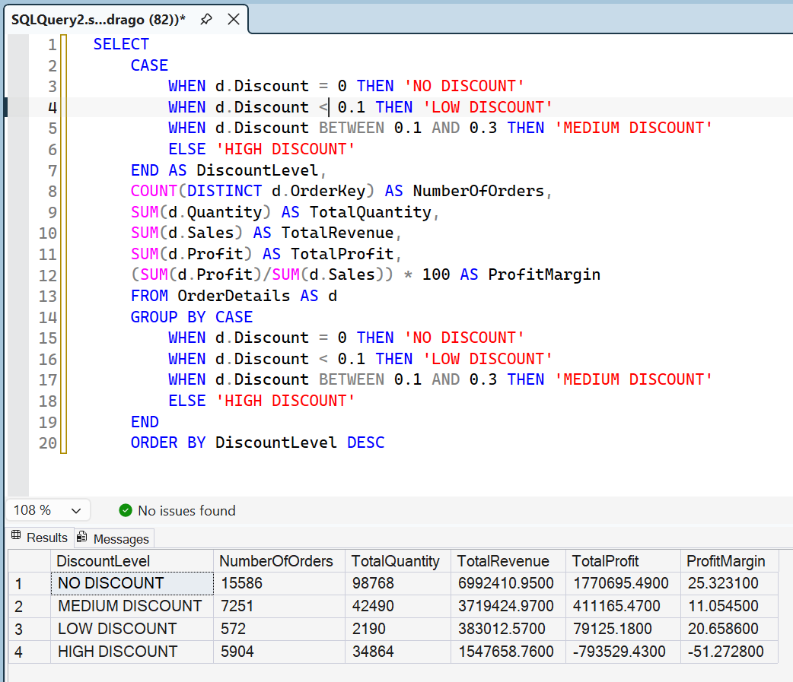
Business Insight:
I arranged the discounts to four discount levels in order to identify at what discount range the sales maximize the profit margin and the quantity of sold products. From the table we see that no discount products generate more sales than the ones with discounts. Therefore, no discounts would be necessary in such situation.

Which shipping modes are the most financially efficient?
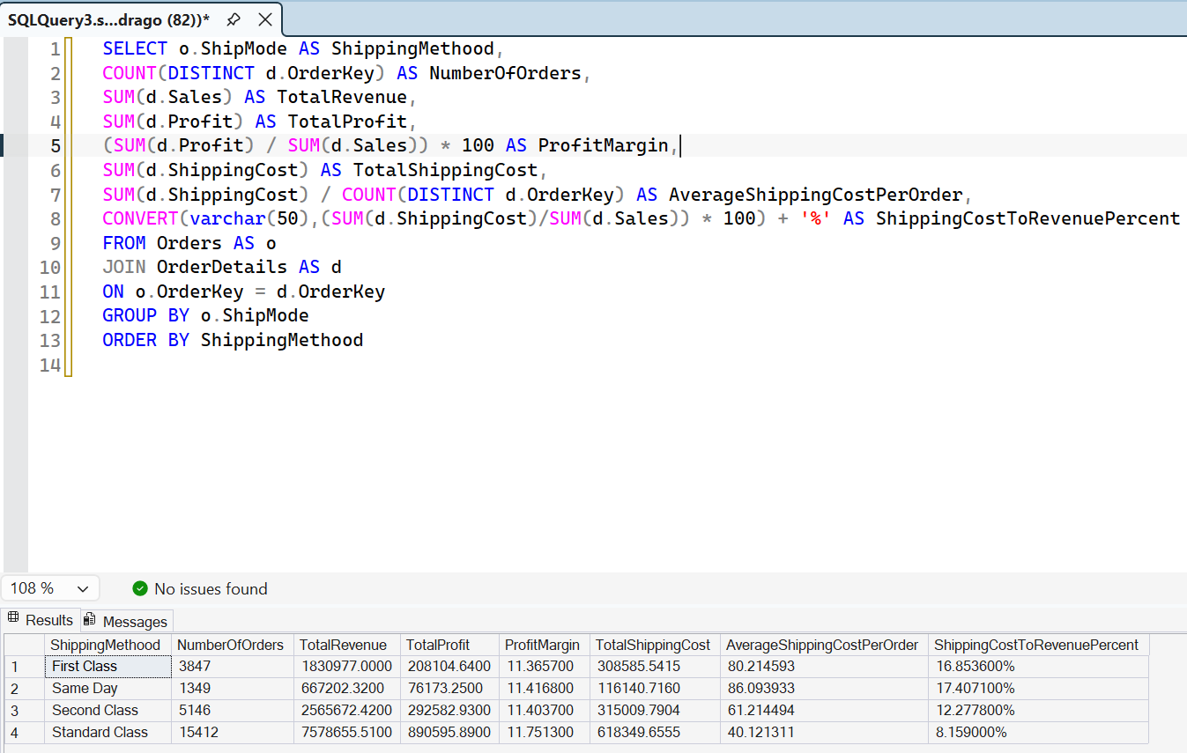
Business Insight:
From this table we can see that the Standard Class is the mist cost- efficient shipping method. The fastest shipping methods which are Some Day and First Class bring higher shipping costs but no higher profit margins.

What are the top 3 most profitable products within each product category?
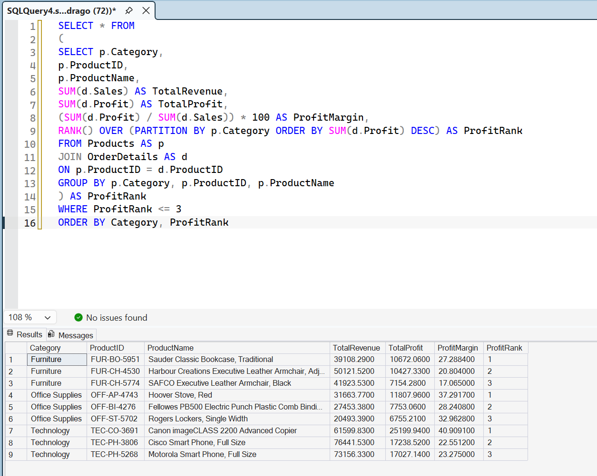
Business Insight:
This table shows us the top 3 products generating us the highest profit in our business.

Which individual sales transactions generated the largest losses, and what characteristics do they have in common?
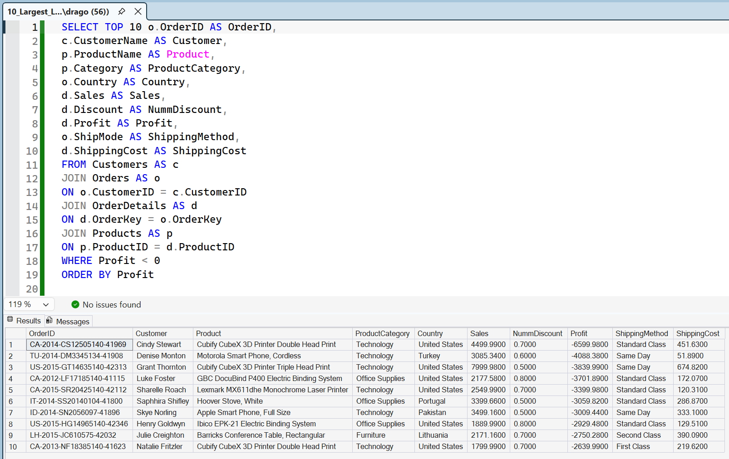
Business Insight:
In this table I show the transactions with the greatest losses in the business and their most important characteristics in order to be clear what are the reasons for them. Here we identify that the lowest negative profits are strongly associated with high discounts above 50% or 0.50 in the NummDiscount table.

